Big Decorations that Fold Flat
Conference Plan (1 Hour Plan)

Purpose Statement

This conference will allow participants to discover ways to decorate for VBS with easy to make decorations that fold flat or collapse for easy storage and mobility. This outline will assist conference leaders with ideas for decorating general or specific conferences.

Before the Session

Focal Wall, Room Setup, & Decoration Ideas

Locate the wall seen first upon entering the room. Hang the Outback backdrop on the wall or suspended (stretched) from the ceiling with bungee cords attached on both sides of the backdrop to the ceiling tracks. Two tables should flank both sides of the scene creating a semi-circle shape to the area.

Plan the left and right side walls of the room to locate the G’day Café scene, Lighthouse Harbor and Opera House stage. If the room is too small, consider grouping the café and lighthouse or placing them in the hallway as you enter.

Place packed decoration items for each area in the planned locations. Conferees will participate and observe as the items are unpacked and set into place. All decorations will be set up during the conference.

Resources to Collect & Prepare

*Note: All spray paint must be flat not gloss.

Outback Back Drop
Queen size Tan Sheet
2 Bungee Cords
Spray paint- Blue, Yellow, Orange
Water Based Paint- brown and green
Small set of Grauments
Paint Brushes

Ayers Rock
2 Foam Boards
Dark Orange Fabric
Wide Tape
Spray Paint- Black and or Brown

Grassland
2 Foam Boards- Black
Water Based Paint- Light Gold and Green
Paint Brushes

Table Clothes
Earth Tone Colors to fit 8 foot tables
White Felt
Black Felt
Glue or Velcro Dots

Train
Black Foam Board
24 Tongue Depressors or Jumbo Craft Sticks
Silver or Gray Tape
Gray Construction Paper
White Poster Board
Black Permanent Marker
New Toilet Plunger
Velcro Dots

Crafts Crossing
Yellow Poster Board
Black Permanent Marker
New Toilet Plunger
Velcro Dots

Craft Shelf
Project Board
3 Project Board Toppers

Kangaroo and Boab Trees
Foam Board
1 Can Insulating Spray Foam
Brown Spray Paint
4 Green Foam Sheets

G’Day Café
Table and Two Folding Chairs
Small Décor Table with 3 Removable Legs
Brown Tablecloth
3 yards Aborigines like Fabric
Bud Vase
Silk Flowers
Small 8 ½ x 11 Piece Poster Board or Card Stock
Folding Easel
Poster Board or G’Day Café Sign

Oprah House
Curtain
Queen or King Size Dark Red Sheet
Gold Trim (Ric-Rack or Ribbon)
2 Bungee Cords
Stage
Tan Twin Size Sheet
Permanent Markers- Black and Brown
1 Package Pipe Insulation Foam (4 pieces)
4 Aluminum Loaf Pans
Clear C7 Christmas Lights and cord
Wide Tape

Harbor
2 Canvas Clothes Hampers (collapsible)
3 Black Poster Boards
Velcro Dots
Foam Board
Black and Brown Spray Paint
Blue Sheet or Paper

Audio/Visual Needs

Outback Focal Wall
Backdrop- Using the line drawing, project the sunset onto a queen size tan sheet. Use spray paint to create the sky and brushes to paint the ground area. Add grauments across the top for easier display.
Ayers Rock- Using a couple of packing boxes or collapsible clothes hamper, place a circle cut foam board three foot diameter on top. Cover with dark orange fabric. The fabric can be spray painted with black and brown spray paint to create darker crevasses in the rock.
Grassland- Using the Outback backdrop pattern, cut grass clumps from foam board. Paint the blades of grass with light gold and green colors starting at the bottom and pulling the brush upward to the point of each blade.

Focal Wall Tabletops
Tablecloths- Purchase tablecloths or fabric in earth tone colors. Be sure the cloth reaches the floor in front of the table. Paint grass clumps with a brush along the front of the cloth where the cloth meets the floor. Using the sheep pattern, enlarge the pattern and cut the shape from white felt or paper. Add black felt for face and legs. Attach sheep to table cloths with glue or Velcro dots if you prefer it to be removable.
Train- Enlarge the patterns and color all three cars with markers. Glue each car to foam board and tape a triangle of foam board to the back as a prop. The triangle should be able to fold flat. Tracks- Use tongue depressors or jumbo craft sticks as railroad ties. Silver or gray tape is cut into thin strips to be taped on the sticks as rails. Use gray construction paper under the track. You can sponge paint grays, blues and black paint combinations to simulate gravel if desired. Railroad crossing sign- Cut two strips of white poster board (4” x 12”), Attach the two strips in the middle with a velcro dot to make the sign shape. Use a permanent black marker to write the bold letters “RAILROAD CROSSING”. Attach the sign to a new toilet plunger handle so it will stand freely on the table.
Crafts Crossing- Print “Crafts Crossing” on a yellow caution sign made from yellow poster board. Secure it to the handle of a new toilet plunger. The plunger will let the sign stand on the table and easily disassembles for packing.
Craft shelf- Use a project board with shutter like panels that open. The project board will stand on the table as the back and sides of the shelf. You will be adding three shelves. You can purchase project board toppers that match the color of the project board or make your own shelves out of boxes and cover them with contact shelf paper. One shelf will sit on top the other two shelves will be located in the center and the table will be the bottom surface. To create the middle shelves, close the project board panels and measure down approximately one third on both sides and draw a line across. Repeat this again approximately two thirds down or at any level you choose. This will mark both sides so the shelves will be even. Cut along the line with a knife being careful not to cut the back of the project board. Cut a line about an eighth inch wide or just enough room for the topper to slide in as the shelf. It should fit snug so tape will not be required. The shelves can hold several items as long as heavier objects are sitting on the table not the shelf.
Kangaroo- Using the pattern, color and glue to foam board. Cut a triangle prop and tape to the back so it can stand freely. Option: Copy, enlarge and print clip art from www.lifeway.com/vbs

G’Day Café
Table and Chairs- Use a wooden table with three removable legs & table cloth. Make slip covers for the chair backs by sewing or gluing fabric to fit standard folding chairs found in most classrooms. Using a permanent marker, write “The G’Day Café” on the slip covers. Place a paper tent folded sign on the table listing the snack special for the day beside a small bud vase of silk flowers.
Place a G’Day Café sign on a folding easel near the table.

Opera House
Curtain- Purchase a dark red sheet (Queen or King Size). Fold over the top of the sheet approximately 12” as the top or the valance of the curtain. Glue gold ribbon or ric-rack along the edge or add other trim you prefer. Create the opening to the curtain by cutting the sheet into equal halves from the bottom to the top of the valance (careful to not divide completely). Add any trim to the edges of both opening parts of the curtain. Attach the curtain to the wall. If the ceiling has tracks and tiles, use bungee cords on each end to stretch and suspend from the ceiling.
Stage- The wood floor pattern can be traced with markers on a tan or brown sheet then lay it on the ground and secure with tape on the edges. Stage lights are made with pipe insulation foam, aluminum loft pans with C-7 Christmas lights (2 per pan). Cut holes in the bottom of the pans for two lights and assemble. Skip two light sockets on the cord (remove bulbs) and continue until each pan is completed. Remove all extra bulbs. Place all the wire in the pipe insulation pieces with the pans spaced evenly. Arrange the stage lights around the sheet as light bars and tape to floor if needed.

Harbor
Lighthouse- Stack two white or ivory canvas clothes hampers. Using black poster board, remove center squares to create a ladder-like shape. Laminate or use clear contact paper to create the look of window panes. Wrap the laminated poster board around the top of the hamper and secure with Velcro dots for easy removal later. Create the roof by cutting a circle of black poster board with a pie shape cut out. Attach the two edges to make a cone. Secure the edges with Velcro dots and place on top of the lighthouse.
Rocks- Cut five rock shape pieces at a variety of sizes. Spray paint the rock shapes with brown and black flat paint.
Water- Use a blue sheet (substitute sheet with blue paper, tarp or fabric)

During the Session

Procedure Steps

There are six sections to this conference and some sections take more time to complete. Practice presenting this material and time yourself so it flows smoothly covering all the items.

1. Welcome conferees and introduce yourself. Briefly describe your experience with VBS and decorations. Remember to include the good and frustrating experience in order to identify with your audience.

Explain that this conference will not only describe ways to decorate for VBS, but also explore ways to fold and store decorations for easy mobility. This is essential for conference leaders and promotional opportunities.

2. Begin with the focal wall by explaining the backdrop materials and how to make the backdrop. Be sure to give tips from your experience so conferees will know easy ways to accomplish the task as well as what to avoid. Help the conferees understand you will unpack and decorate the space as you describe the decorations. Encourage conferees to write down ideas and offer alternative ideas everyone can benefit from hearing.

Place the Ayers Rock display on the floor centered in front of the scene. Tables will flank both sides of the scene creating a semi circle shape to the area. Place the prepared table cloths on the tables (if you did not glue the sheep to the tablecloths, attach those now). Now add the tracks, train, and signs on one table. Include any other materials you desire to display. TIP- Be careful to not add so much to the table that the primary decorations are lost. Additional decorating ideas can be placed on a separate display. On the other table place one or more Crafts Crossing signs and display shelf. Explain as you assemble and place the kangaroo on the table near the sign. Feel free to display crafts and materials. Caution conferees about the weight limit of the shelves.

The final part is to add a few grassland clumps on the floor near the table cloths. Tip- Adding too many clumps will create problems for you as you lead the conference. Try to place them nears the tables (sheep) and Ayres Rock. Point out that inflatable animals and objects are another good way to bring items that will pack flat.

Ask for questions and comments about the display or the set up process. Allow other ideas and ways to simply the scene. Tip- Remind conferees they should pack the box or luggage in reverse order as much as possible for easier set up at the conference site.

3. Turn your attention to the Harbor display. Explain that a paper lighthouse would be very easy to roll up and travel in a tube. It can be hung using command strips instead of tape. If tape is preferred, be sure to put strips of tape on the back of the paper so when tape curls are removed the paper will be protected and not rip.

Begin unpacking and assembling the lighthouse clothes hampers. Work on the top section first while describing to the conferees how you made each piece. When you have finished the top, stack the hampers and move them in place. Spread a blue sheet as water and stand up the rocks around the lighthouse. Tip- Attach paper clouds and missions posters to the wall to help define the scene if you desire. Allow conferees to ask any questions or say comments. Ask for ideas to add to this scene and complement their creativity.

4. Move across the room to the Opera House scene location. Explain to conferees that the Opera House is often seen from the outside of the building. Ask conferees, “What are some ways you can make the building and fold it flat?” After a short discussion, offer the idea to use a small dome tent. Cover the tent with a white sheet and add white poster board fins hinged with white tape across the top. The fins can be attached to the sheet using Velcro dots.

Begin setting up the Opera House stage by hanging the red curtain just like the Outback backdrop. If this is too difficult with conferees in the room, please hang it before the conference begins. You can pull back the curtain with ties if desired. Tip- If you hang the curtain from the ceiling consider moving it away from the wall slightly so kids can stand behind the curtain and come out on stage for the music performance. Lay the sheet painted like a wooden floor on the floor. Secure the edges with tape. Lay the stage lights along the front edge of the stage and plug in the lights. Tip- Remember to bring an extension cord in case outlets are not close by. Use a folding easel to set on stage with a sign that says, “Music Opera House”. Invite questions and comments.

5. Direct conferee’s attention to the G’Day Café location. Assemble the small table with three legs; put the tablecloth and topper fabric on the table. Ask two conferees to bring their chairs to the table and give them each a chair slip cover for the back of their chair. Tip- You should look in the dollar fabric to find something with a native aborigines flare. Sewing is not required. Consider using a stapler or hot glue to achieve the same product. Ask them to put the slip covers on the chairs sit down at the table. Allow the two conferees to put the tent sign on the table as well as the bud vase and flowers. Set up the easel and place the “G’Day Café” sign on it. Invite questions and comments.

6. Close by challenging conference leaders to set up their conference before they pack. Pack items needed first on top for easier set up and better time management. Be sure to pack a baggie of tools to assist in setting up. Consider bringing; scissors, masking tape, duct tape, scotch tape, command strips, paper clips, string, and a variety of markers. Tip- Show a preassembled bag and add other simple tool ideas you have. Remind conferees that they only need what they set up ahead of time. Too often, conference leaders pack too much because they don’t plan more carefully. Be a good planner, set up before you pack and take just what you need and you won’t be so tired from carrying so much stuff.

**Note- Invite conferees to repack all the items if time allows or invite conferees to stay and help repack.

Luggage Idea!

After all the bags are unpacked, instead of hiding the luggage, display it at the door where conferees enter. Use contact shelf paper and create stickers and luggage tags that read:

“Australia or BUST!” “All Aboard!”
“HOP on the Train!” “Boomerang Express VBS July 20-25”
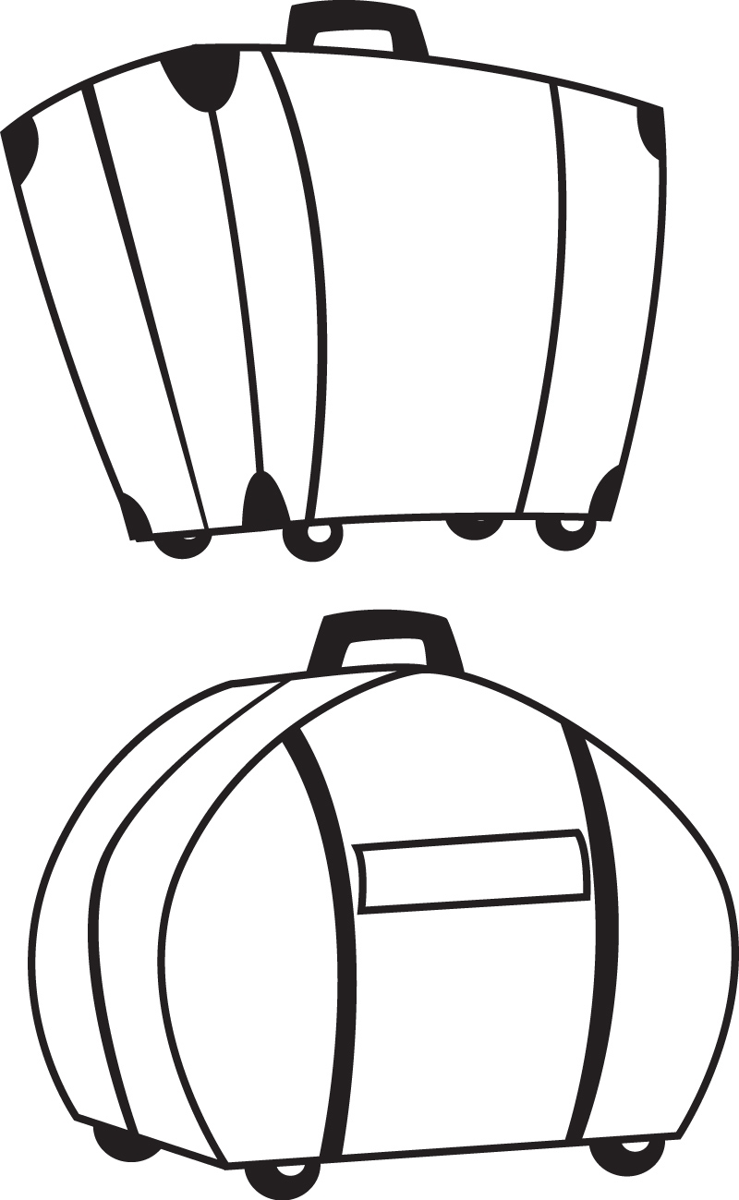
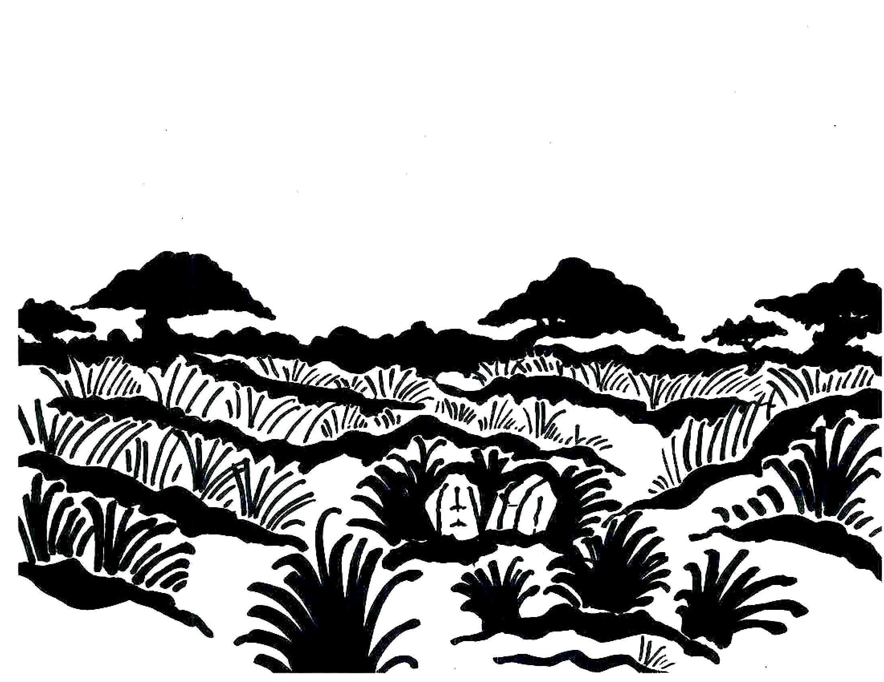
Outback Backdrop Pattern

Boab Tree
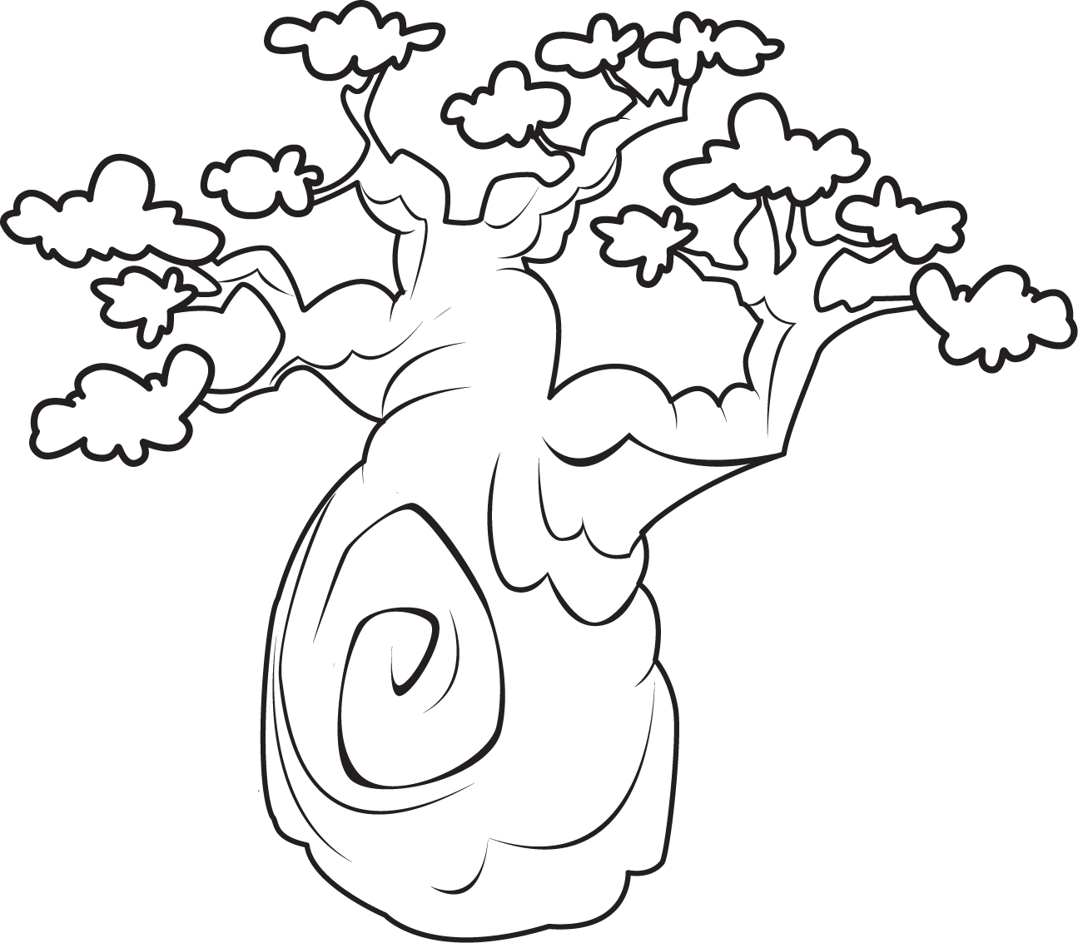
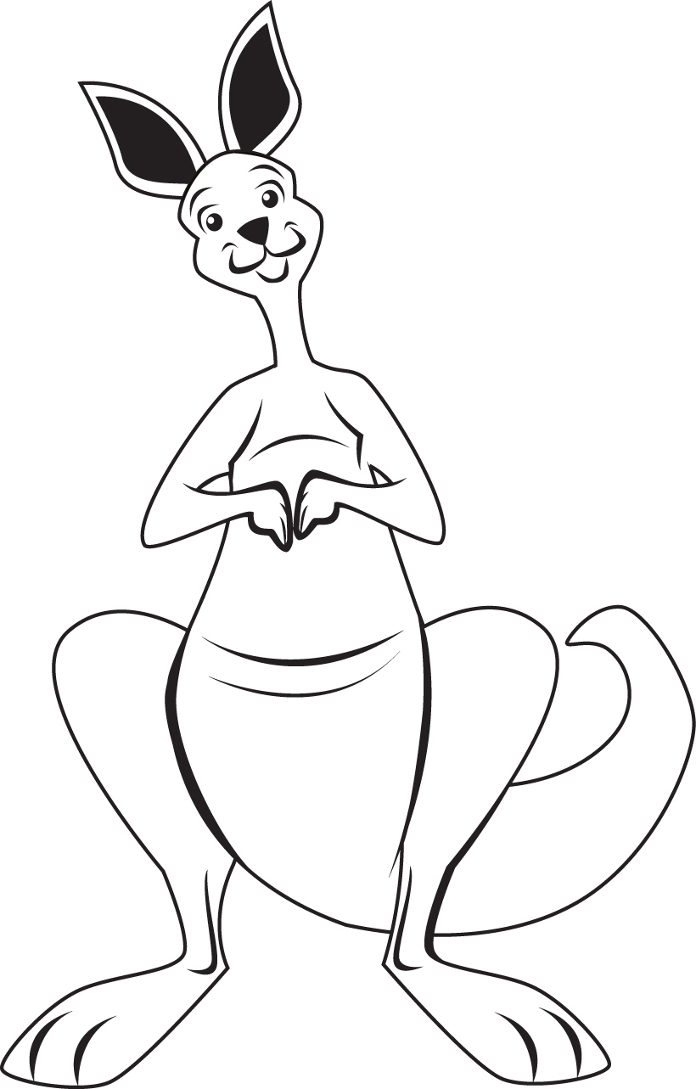

Kangaroo
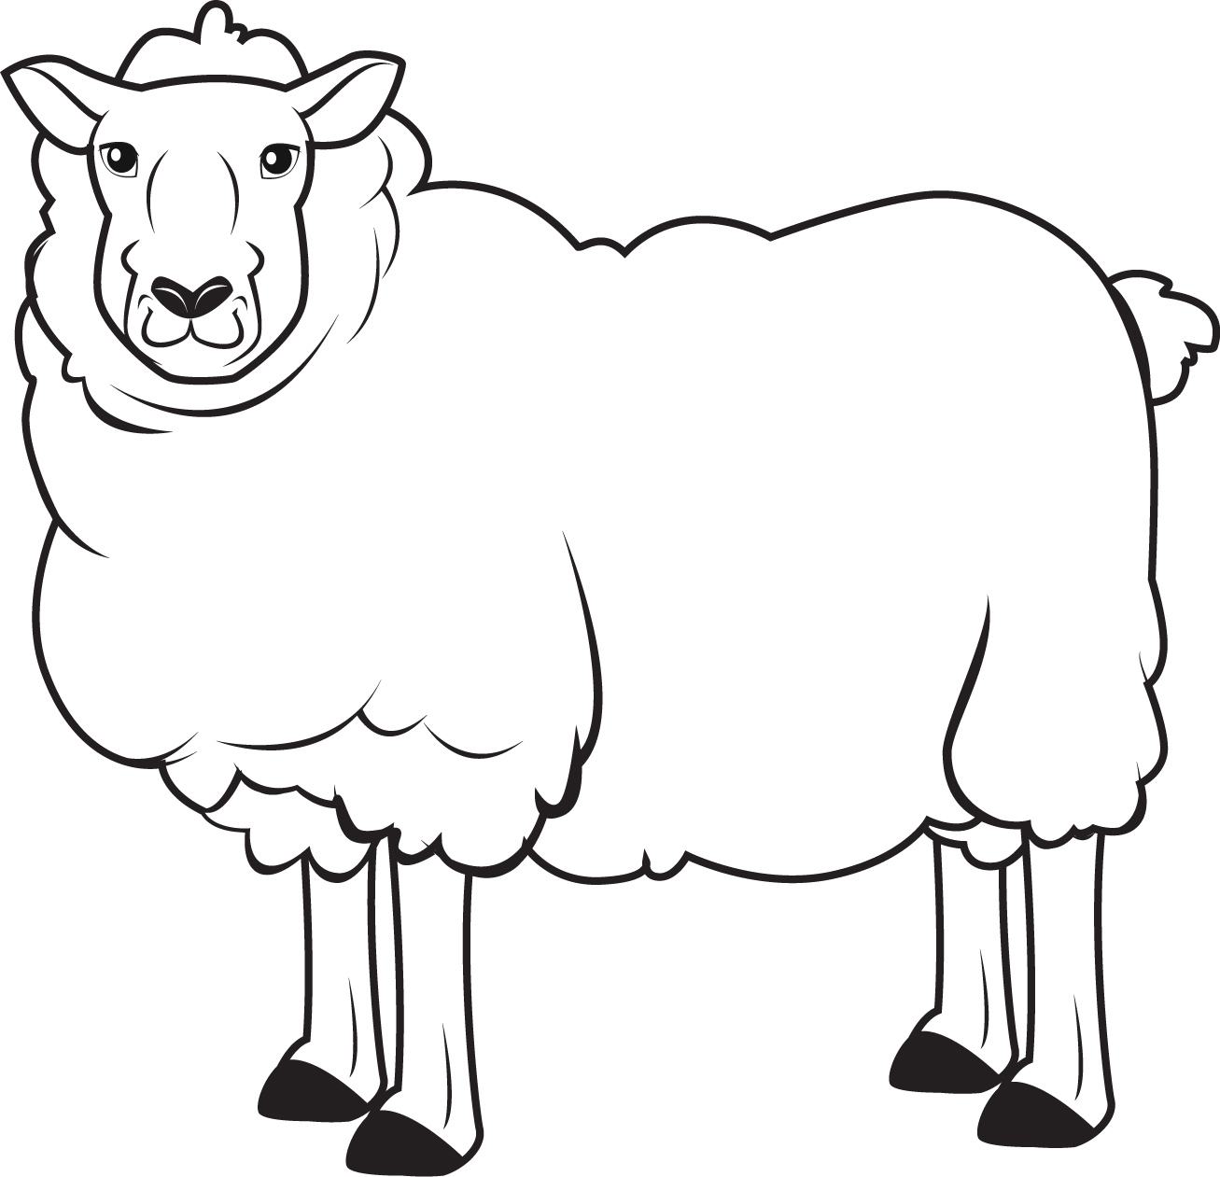

Sheep

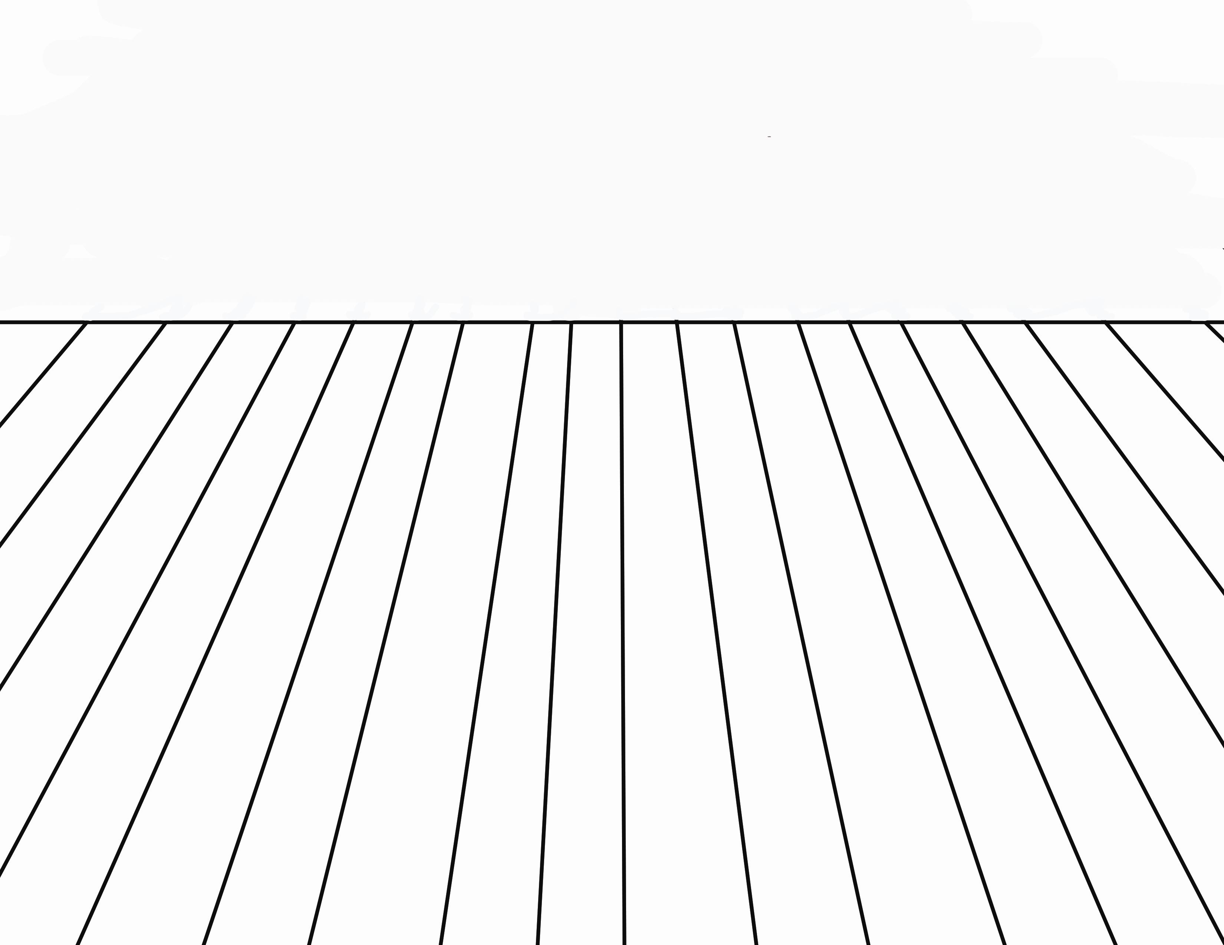

Opera House Stage Floor

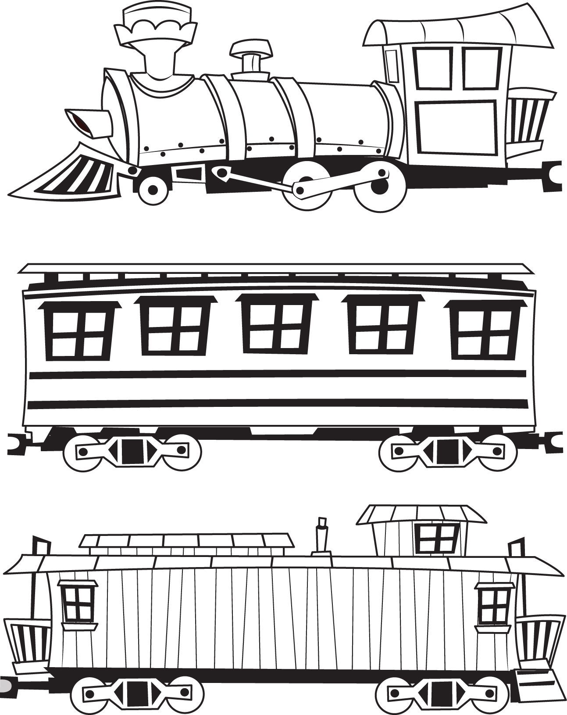

Train Cars

